Project Planning Phase
Project Planning Template (Product Backlog, Sprint Planning, Stories, Story points)

Date | 18 October 2022
Team ID | LTVIP2026TMIDS36439
Project Name | Toy craft tales: tableau’s vision into toy manufacturer data
Maximum Marks | 8 Marks

Product Backlog, Sprint Schedule, and Estimation (4 Marks)
Use the below template to create product backlog and sprint schedule
Sprint | Functional Requirement (Epic) | User Story Number | User Story / Task | Story Points | Priority | Team Members
Sprint-1 | Data collection & extraction from database | USN-6 | As a sales manager ,I want to see a map of sales by region so that I can identify which toy categories are trending in specific cities. | 3 | High | Jajjimoggala. Gangotri
Sprint-1 | Data preparation | USN-7 | As a warehouse lead,I want to see real -time stock levels of best- selling toys so that I can prevent “ out- of-stock “scenarios during peak seasons. | 2 | High | Potnuru.meghana
Sprint-2 | Dashboard | USN-8 | As a marketing executive, I want to filter toy sales by age group ( e.g 3-5 years,6-10years)to better target our next ad campaign. | 2 | Medium | Ganthi.Gopika
Sprint-1 | Story | USN-9 | As a finance officer,I want to compare the manufacturing cost vs.selling price per toy to see which products have the highest profit margins. | 3 | High | Gouda.Deepika
Sprint-1 | Performance testing | USN-10 | As a business analyst,I want to see a 6- month sales for caste based on historical data to plan raw material order for the next quarter. | 5 | Medium | Janapareddi.pooja
 | Web integration | USN-11 | As a dashboard user,I want to click on a specific toy image and see its individual performance metrics instantly. | 2 | Low

Project Tracker, Velocity & Burndown Chart: (4 Marks)

Sprint | Total Story Points | Duration | Sprint Start Date | Sprint End Date (Planned) | Story Points Completed (as on Planned End Date) | Sprint Release Date (Actual)
Sprint-1 | 20 | 6 Days | 28 Jan 2026 | 04 feb 2026 | 05 feb 2026 | 06 feb 2026
Sprint-2 | 20 | 6 Days | 07 feb 2026 | 10feb 2026 | 12 feb 2026 | 14 feb 2026
Sprint-3 | 20 | 6 Days | 15 feb 2026 | 16 feb 2026 | 17 feb 2026 | 18 feb 2026
Sprint-4 | 20 | 6 Days | 20 feb 2026 | 22 feb 2026 | 24 feb 2026 | 26 feb 2026

Velocity:
Imagine we have a 10-day sprint duration, and the velocity of the team is 20 (points per sprint). Let’s calculate the team’s average velocity (AV) per iteration unit (story points per day)
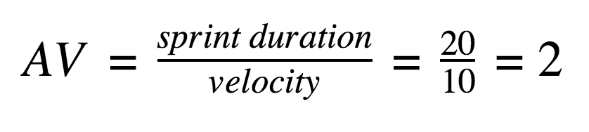

Burndown Chart:
A burn down chart is a graphical representation of work left to do versus time. It is often used in agile software development methodologies such as Scrum. However, burn down charts can be applied to any project containing measurable progress over time.

https://www.visual-paradigm.com/scrum/scrum-burndown-chart/
https://www.atlassian.com/agile/tutorials/burndown-charts

Reference:
https://www.atlassian.com/agile/project-management
https://www.atlassian.com/agile/tutorials/how-to-do-scrum-with-jira-software
https://www.atlassian.com/agile/tutorials/epics
https://www.atlassian.com/agile/tutorials/sprints
https://www.atlassian.com/agile/project-management/estimation
https://www.atlassian.com/agile/tutorials/burndown-charts

